# **1.Abstract**

This project is being developed for the purpose of event booking where the customer will be getting to know about different kinds of events and various types of information’s which “N K Events” provide. The customer can choose event of his choice and make the payment for the respective event. Admin can view the events which have been booked and he can also check the queries from the customer. The application is entitled as “EVENT BOOKING SYSTEM”.

# **2. Introduction**

### **2.1Purpose**

The main objective of the web application is to provide the different service information which an event booking provides, where the client can book /select the event of his desire .such as Photography, birthday, wedding, corporate events and so on.

### **2.2 Scope**

Over all event booking process has been simplified for the customer through this application. The customer can contact the event manager for more subtle elements and interact with them offline. All the data with respect to the occasion will be put away in database, where the admin will be affirmed with the booked occasions.

### **Definitions, acronyms, and abbreviations**

**Admin:** System administrator who is given specific permission for managing and controlling the System.

**User:** Client/user/customer.

### **2.4 Overview**

**Software Requirement Specification(SRS)** contains the overall description of the system; it states the general factor that affects the product and its requirements, specific requirements and defining the constraints on the system. This project is used by admin and (client/user/customer) public. The users can select the events according to time and date of his choice. The registered events can be viewed by the admin and also interact with customer/client.[1]

# **3. Overall description**

### **3.1 Product perspective**

The Event Booking system is a platform which helps all functionaries of an event booking company is semi –automated. Starting from event selection to till booking and (payment.)

### **3.2 Product functions**

Event booking system allows the user to place order/book an event online.

Admin and user perform the following functions.

* The user book the event.
* The user can make secure payment through online payment portal (PayU)
* The admin gets to know about the event.
* The date and event is blocked for particular user.

### **3.3 User characteristics**

**ADMINISTRATOR**

* Overall maintenance of the system.
* Process the booked event.
* Interact with user.

**USER**

* Can book an event.
* Can pay for the particular event online
* Can interact offline with event manger.
* Can view the difference services provided

### **3.4 Constraints**

Any user can have access to the system.

### **3.5 Assumptions and dependencies**

One of the assumptions of the system is that, the user is familiar with an internet browser and also familiar with handling the computer. User of the system should know English knowledge as the interface is developed in English.

# **4. Specific Requirements**

### **4.1 External Interface requirements**

#### **4.1.1 User interface:**

##### **4.1.1.1 User:**

* **Home page:** includes events, gallery, booking, payment, contact.
* **Events:** events which are going to happen.
* **Gallery:** images of events which were undertaken.
* **Booking:** Book the events
* **Payment:** payments can be done for the respective booked event.
* **Contact :** can enquire with the admin regarding events.

##### **4.1.1.2 Admin**

* **Login page:** The admin will login using his/her login credentials.
* **View:** can view the booked events and clients information.
* **Customer Queries** : can view the queries of customer

#### **4.1.2 Hardware interface:**

**General Specifications Minimum Requirements**

**For Developer:**

|  |  |
| --- | --- |
| **Hard Disk** | 500 GB |
| **RAM** | 8.00 GB |
| **Processor** | Intel® Core™ i5-3337U CPU@1.80GHz |

**For User:**

|  |  |
| --- | --- |
| **Hard Disk** | 500 GB |
| **RAM** | 4.00 GB |
| **Processor** | Intel® Core™ i7-4790 CPU@3.60GHz |
| **Operating System** | Windows 7 |

#### **4.1.3 Software Interface:**

**General Specifications Minimum Requirements**

**For Developer:**

**Website:**

|  |  |
| --- | --- |
| **Front End** | HTML 5, CSS 3 |
| **Scripting Language** | PHP 5.5.12 |
| **Back End** | MySQL 5.6.17 |
| **Browsers** | Google Chrome 56.0.2924.87, Mozilla Firefox 41.0.1 |
| **Text Editor** | Sublime Text 3, Notepad++ |
| **Web Server** | Xampp v3.2.1 |

**For User:**

**Website:**

|  |  |
| --- | --- |
| **Front End** | HTML 5, CSS 3 |
| **Scripting Language** | PHP 5.5.12 |
| **Back End** | MySQL 5.6.17 |
| **Operating System** | Windows 7 |
| **Browsers** | Google Chrome 56.0.2924.87, Mozilla Firefox 41.0.1 |
| **Web Server** | Xampp v3.2.1 |

#### **4.1.4 Communication Interface:**

The user can send feedback to the admin.

### **4.2 System Features:**

#### **4.2.1 Introduction/Purpose of features:**

The system supports well-defined set-up supporting multiple users for booking. The system bridges the gap between user and event manger via online 24/7, reduces the waste of energy. And make payment. Added advantage of booking the event online.

#### **4.2.2 Stimulus/response sequence:**

**Stimulus:** The user book an event with specifications.

**Response:** Redirect to the payment module.

#### **4.2.3 Associated Functional Requirements:**

##### **4.2.3.1 Booking Event:**

A client can book an event through the site, thus unique Id is generated.

##### **4.2.3.2 Payment:**

Depending on the client booking the amount of the event will automatically generated [8].

##### **4.2.3.3 Feedback:**

The user can send feedback to the admin via contact us.

### **Performance requirements:**

1. The system should be able to book any number of event and display once its booked successfully.
2. The system should be able to calculate the amount of different event and process this for the payment.
3. The system should be able to pass the payment successfully
4. The system has to be secured with the necessary validations.
5. The system should be able to communicate to database to verify the payment.

### **4.4 Other requirements:**

* 1. **Availability:**

The system shall be available on 24/7.

* 1. **Security:**

The system shall validate user’s details.

The admin shall login with the unique login credentials

* 1. **Interoperability:**

The admin makes sure that the information received from the user regarding the booking is genuine and will be stored in the database.

* 1. **Accessibility:**

The application can be accessed easily by the user for booking events and making payments.

* 1. **Efficiency:**

This involves accuracy, timeliness and comprehensiveness to the system.

* 1. **Usability:**

The application should satisfy maximum number of user needs.

* 1. **Maintainability:**

The admin should maintain correct schedule of the booking and payment.

* 1. **Extensibility:**

It should be able to accommodate the variations like different booking to be handled easily.

# **5. Design**

### **5.1 Tables**

**user**

|  |  |  |  |  |
| --- | --- | --- | --- | --- |
| Attribute | Datatype | Size | Constraint | Extra |
| uid | int | 10 | Primary key | auto increment |
| firstname | varchar | 25 | Not null |  |
| lastname | varchar | 25 | Not null |  |
| email | varchar | 25 | Not null |  |
| password | varchar | 25 | Not null |  |
| phone | varchar | 25 | Not null |  |
| question | varchar | 25 | Not null |  |
| answer | varchar | 25 | Not null |  |

**feedback**

|  |  |  |  |  |
| --- | --- | --- | --- | --- |
| Attribute | Datatype | Size | Constraint | Extra |
| fid | int | 10 | Primary key | auto increment |
| firstname | varchar | 25 | Not null |  |
| email | varchar | 25 | Not null |  |
| phone | varchar | 25 | Not null |  |
| reason | varchar | 25 | Not null |  |

**birthday**

|  |  |  |  |  |
| --- | --- | --- | --- | --- |
| Attribute | Datatype | Size | Constraint | Extra |
| Bid | int | 10 | Primary key | auto increment |
| Uid | int | 10 | Not null |  |
| Location | varchar | 25 | Not null |  |
| Date | varchar | 25 | Not null |  |
| Time | varchar | 25 | Not null |  |
| decorationtype | varchar | 25 | Not null |  |
| Decorationprice | varchar | 25 | Not null |  |
| caketype | varchar | 25 | Not null |  |
| cakeprice | Varchar | 25 | Not null |  |
| Phototype | Varchar | 25 | Not null |  |
| photoprice | Varchar | 25 | Not null |  |
| totalprice | varchar | 25 | Not null |  |

**wedding**

|  |  |  |  |  |
| --- | --- | --- | --- | --- |
| Attribute | Datatype | Size | Constraint | Extra |
| Bid | int | 10 | Primary key | auto increment |
| Uid | int | 10 | Not null |  |
| Location | varchar | 25 | Not null |  |
| Date | varchar | 25 | Not null |  |
| Time | varchar | 25 | Not null |  |
| decorationtype | varchar | 25 | Not null |  |
| Decorationprice | varchar | 25 | Not null |  |
| Makeup | varchar | 25 | Not null |  |
| makeupprice | Varchar | 25 | Not null |  |
| Phototype | Varchar | 25 | Not null |  |
| photoprice | Varchar | 25 | Not null |  |
| totalprice | varchar | 25 | Not null |  |

**Photoshoot**

|  |  |  |  |  |
| --- | --- | --- | --- | --- |
| Attribute | Datatype | Size | Constraint | Extra |
| Bid | int | 10 | Primary key | auto increment |
| Uid | int | 10 | Not null |  |
| Location | varchar | 25 | Not null |  |
| Date | varchar | 25 | Not null |  |
| Time | varchar | 25 | Not null |  |
| Phototype | Varchar | 25 | Not null |  |
| photoprice | Varchar | 25 | Not null |  |

### **5.2Use Case Diagram**

### **5.2.1 Use Case Diagram**

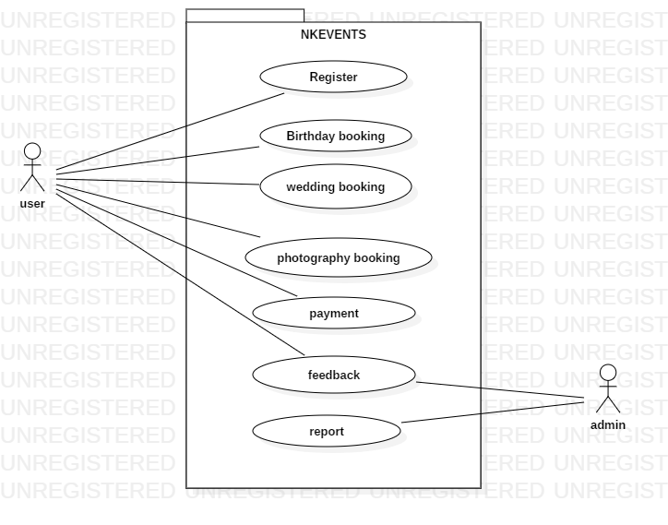

### **Fig. 1 Use Case diagram**

### 

### **5.3 Class Diagram**

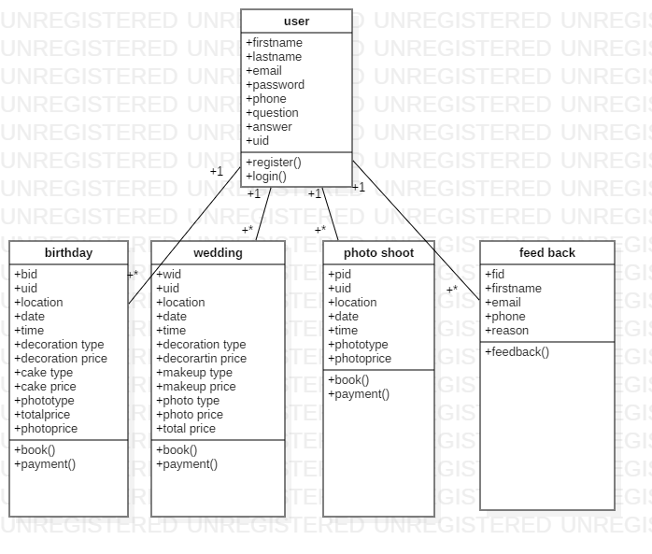

### **Fig. 2 Class Diagram**

### **5.4 Sequence Diagram**

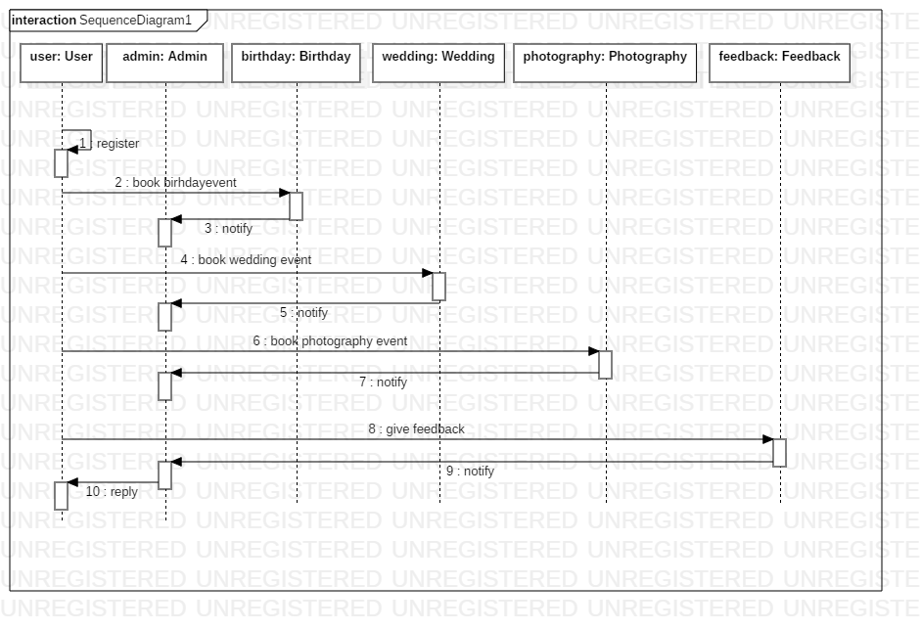

**Fig. 3 Sequence diagram**

**5.4.2 Activity diagram**

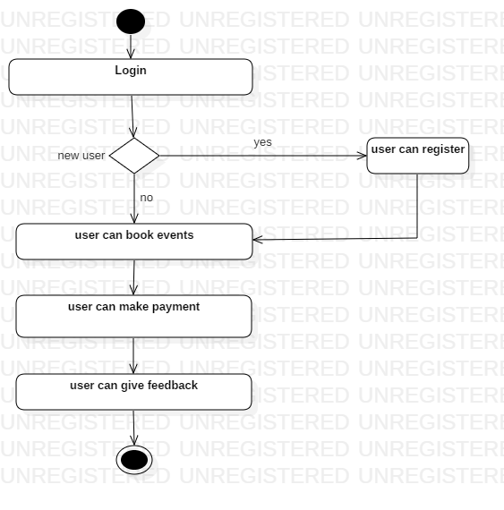

**Fig. 4 Activity diagram**

### 

### **6.2Technologies Used**

**HTML**

Hypertext Markup Language (HTML) is the standard [markup language](https://en.wikipedia.org/wiki/Markup_language) for creating [web pages](https://en.wikipedia.org/wiki/Web_page) and [web applications](https://en.wikipedia.org/wiki/Web_application). With [Cascading Style Sheets](https://en.wikipedia.org/wiki/Cascading_Style_Sheets) (CSS) and [JavaScript](https://en.wikipedia.org/wiki/JavaScript) it forms a triad of cornerstone technologies for the [World Wide Web](https://en.wikipedia.org/wiki/World_Wide_Web).[Web browsers](https://en.wikipedia.org/wiki/Web_browser) receive HTML documents from a [web server](https://en.wikipedia.org/wiki/Webserver) or from local storage and render them into multimedia web pages. HTML describes the structure of a web page [semantically](https://en.wikipedia.org/wiki/Semantic) and originally included cues for the appearance of the document. [2]

**CSS**

Cascading Style Sheets (CSS) is a [style sheet language](https://en.wikipedia.org/wiki/Style_sheet_language) used for describing the [presentation](https://en.wikipedia.org/wiki/Presentation_semantics) of a document written in a [markup language](https://en.wikipedia.org/wiki/Markup_language). Although most often used to set the visual style of [web pages](https://en.wikipedia.org/wiki/Web_page) and user interfaces written in [HTML](https://en.wikipedia.org/wiki/HTML) and [XHTML](https://en.wikipedia.org/wiki/XHTML), the language can be applied to any [XML](https://en.wikipedia.org/wiki/XML) document, including [plain XML](https://en.wikipedia.org/wiki/Plain_Old_XML), [SVG](https://en.wikipedia.org/wiki/Scalable_Vector_Graphics) and [XUL](https://en.wikipedia.org/wiki/XUL), and is applicable to rendering in [speech](https://en.wikipedia.org/wiki/Speech_synthesis), or on other media. Along with HTML and [JavaScript](https://en.wikipedia.org/wiki/JavaScript), CSS is a cornerstone technology used by most websites to create visually engaging WebPages, user interfaces for [web applications](https://en.wikipedia.org/wiki/Web_applications), and user interfaces for many mobile applications. [3]

**JavaScript**

JavaScriptoften abbreviated as "JS", is a [high-level](https://en.wikipedia.org/wiki/High-level_programming_language), [dynamic](https://en.wikipedia.org/wiki/Dynamic_programming_language), [untyped](https://en.wikipedia.org/wiki/Untyped_language), [interpreted](https://en.wikipedia.org/wiki/Interpreted_language) [run-time](https://en.wikipedia.org/wiki/Runtime_system) [language](https://en.wikipedia.org/wiki/Programming_language). It has been standardized in the [ECMAScript](https://en.wikipedia.org/wiki/ECMAScript) language specification. Alongside [HTML](https://en.wikipedia.org/wiki/HTML) and [CSS](https://en.wikipedia.org/wiki/CSS), JavaScript is one of the three core technologies of [World Wide Web](https://en.wikipedia.org/wiki/World_Wide_Web) [content production](https://en.wikipedia.org/wiki/Content_engineering); the majority of [websites](https://en.wikipedia.org/wiki/Website) employ it, and all modern [Web browsers](https://en.wikipedia.org/wiki/Web_browser) support it without the need for [plug-ins](https://en.wikipedia.org/wiki/Browser_extension). JavaScript is [prototype-based](https://en.wikipedia.org/wiki/Prototype-based_programming) with [first-class functions](https://en.wikipedia.org/wiki/First-class_function), making it a [multi-paradigm](https://en.wikipedia.org/wiki/Multi-paradigm) language, supporting [object-oriented](https://en.wikipedia.org/wiki/Object-oriented_programming), [imperative](https://en.wikipedia.org/wiki/Imperative_programming), and [functional](https://en.wikipedia.org/wiki/Functional_programming) [programming styles](https://en.wikipedia.org/wiki/Programming_paradigm). It has an [API](https://en.wikipedia.org/wiki/Application_programming_interface) for working with text, [arrays](https://en.wikipedia.org/wiki/Array_data_type), dates and [regular expressions](https://en.wikipedia.org/wiki/Regular_expression), but does not include network, storage, or graphics APIs, relying instead upon APIs made available by its host environment. [4]

**PHP**

PHP is a [server-side scripting](https://en.wikipedia.org/wiki/Server-side_scripting) language designed primarily for [web development](https://en.wikipedia.org/wiki/Web_development) but also used as a [general-purpose programming language](https://en.wikipedia.org/wiki/General-purpose_programming_language). Originally created by [RasmusLerdorf](https://en.wikipedia.org/wiki/Rasmus_Lerdorf) in 1994, the PHP [reference implementation](https://en.wikipedia.org/wiki/Reference_implementation) is now produced by The PHP Development Team. PHP originally stood for Personal Home Page, but it now stands for the [recursive acronym](https://en.wikipedia.org/wiki/Recursive_acronym) PHP: Hypertext Preprocessor. [5]

**XML**

 Extensible Markup Language (XML) is a [markup language](https://en.wikipedia.org/wiki/Markup_language) that defines a set of rules for encoding [documents](https://en.wikipedia.org/wiki/Electronic_document) in a [format](https://en.wikipedia.org/wiki/File_format) that is both [human-readable](https://en.wikipedia.org/wiki/Human-readable_medium) and [machine-readable](https://en.wikipedia.org/wiki/Machine-readable_data). The [W3C](https://en.wikipedia.org/wiki/World_Wide_Web_Consortium)'s XML 1.0 Specificationand several other related specifications—all of them free [open standards](https://en.wikipedia.org/wiki/Open_standard)—define XML.

The design goals of XML emphasize simplicity, generality, and usability across the [Internet](https://en.wikipedia.org/wiki/Internet). It is a textual data format with strong support via [Unicode](https://en.wikipedia.org/wiki/Unicode) for different [human languages](https://en.wikipedia.org/wiki/Language). Although the design of XML focuses on documents, the language is widely used for the representation of arbitrary [data structures](https://en.wikipedia.org/wiki/Data_structure) such as those used in [web services](https://en.wikipedia.org/wiki/Web_service). [6]

### 

### **6.3 Pseudo Code**

**Website:**

Step 1: Accept username and password from user and validate login.

Step 2: Select the event which you hav to plan.

Step 3: The customer enters all the information in html page.

Step 4: Validate all the fields.

Step 5: On click of cancel button terminates the interaction and go back to index page.  
Step 6: Create database.

Step 7: Establish connection.

Step 8: Pick the data from the html and populate in php.

Step 9: Store the values in the database.

Step 10: Payments for the events are done by clicking “pay now”.

Step 11: Give feedback/complaints in the panel provided.

Step 13: User can view gallery, about us by clicking respective menu.

Step 14: On clicking home, redirect to home screen.

Step 15:If user clicks on logout, close the connection with the database and terminate the session.

# **7. Testing**

#### Testing is the process of evaluation a software item to detect differences between given input and expected output. Also to assess the feature of A software item. Testing assesses the quality of the product. Software testing is a process that should be done during the development process. [7]

### **7.1 Unit testing**

Unit testing is the testing of an individual unit or group of related units. It is often done by the programmer to test that the unit he/she has implemented is producing expected output against given input.

* The login module for admin and user has successfully passed the unit testing.
* The module book events have successfully passed the unit testing.
* The module payment has successfully passed the unit testing.
* The contact us module has successfully passed the unit testing.

### **7.2 Integration testing**

Integration testing is testing in which a group of components are combined to produce output. Also, the interaction between software and hardware is tested in integration testing if software and hardware components have any relation.

* Login page and home page for admin and user are integrated successfully and the result is passing.
* Book event and payment page is successfully integrated and the result is passing.
* Book event and customer page is successfully integrated and the result is passing.

### **7.3 Validation**

Validation is to make sure the product satisfies the specified requirements at the end of the development phase. In other words, to make sure the product is built as per user requirements.

* The inputs for all the fields are validated and tested successfully.

### **7.4 System testing**

System testing is the testing to ensure that by putting the software in different environments (e.g., Operating Systems) it still works. System testing is done with full system implementation and environment.

* Event booking as a whole system is tested and the result is passing.

### **7.5 Test Cases**

|  |  |  |  |  |  |
| --- | --- | --- | --- | --- | --- |
| **Test Case ID** | **Test Description** | **Input** | **Actual Output** | **Excepted Output** | **Pass/Fail** |
| **NK1** | **Establishes connection to database with valid credentials** | **Establish connection** | **Database**  **Connection successful** | **Database Connection successful** | **Pass** |
| **NK2** | **Maintains error-free and rich user experience of home page** | **Testing is done** | **Maintained** | **Maintained** | **Pass** |
| **NK3** | **Signup for new valid customer registration** | **Enter customer details** | **Registered successful** | **Registered successful** | **Pass** |
| **NK4** | **Valid customer is login** | **Enter customer credentials** | **Login successful** | **Login successful** | **Pass** |
| **NK5** | **Customer is invalid then error message is displayed saying that invalid customer** | **Enter customer credentials** | **Login unsuccessful error message is displayed.** | **Login successful error message is not displayed.** | **Fail** |

**Table number 1.** **Test Cases for Event Booking System.**

# **8. Conclusion**

“EVENT BOOKING SYSTEM” provides an automated user friendly and easy to use interface to the customers. The client can book an event on date and time of their desire.All modules with respect to the system will function in ease manner. It is favourable for future enhancements.

# **9. Future Enhancements**

* Make complete payment.
* Two way communication.
* Mobile application and alerts.

# **10. Bibliography**

1. <https://en.wikipedia.org/wiki/Software_requirements_specification>
2. <https://en.wikipedia.org/wiki/HTML>
3. <https://en.wikipedia.org/wiki/Cascading_Style_Sheets>
4. <https://en.wikipedia.org/JavaScript>
5. <https://en.wikipedia.org/wiki/PHP>
6. <https://en.wikipedia.org/wiki/XML>
7. <https://www.codeproject.com/Tips/351122/What-is-software-testing-What-are-the-different-ty>
8. https://www.payumoney.com/dev-guide/apireference.html?utm_source=google&utm_medium=search&utm_term=payumoney integration in android

# **11. Screenshots**

**Screenshots for Website**

**11.1 Home Page**

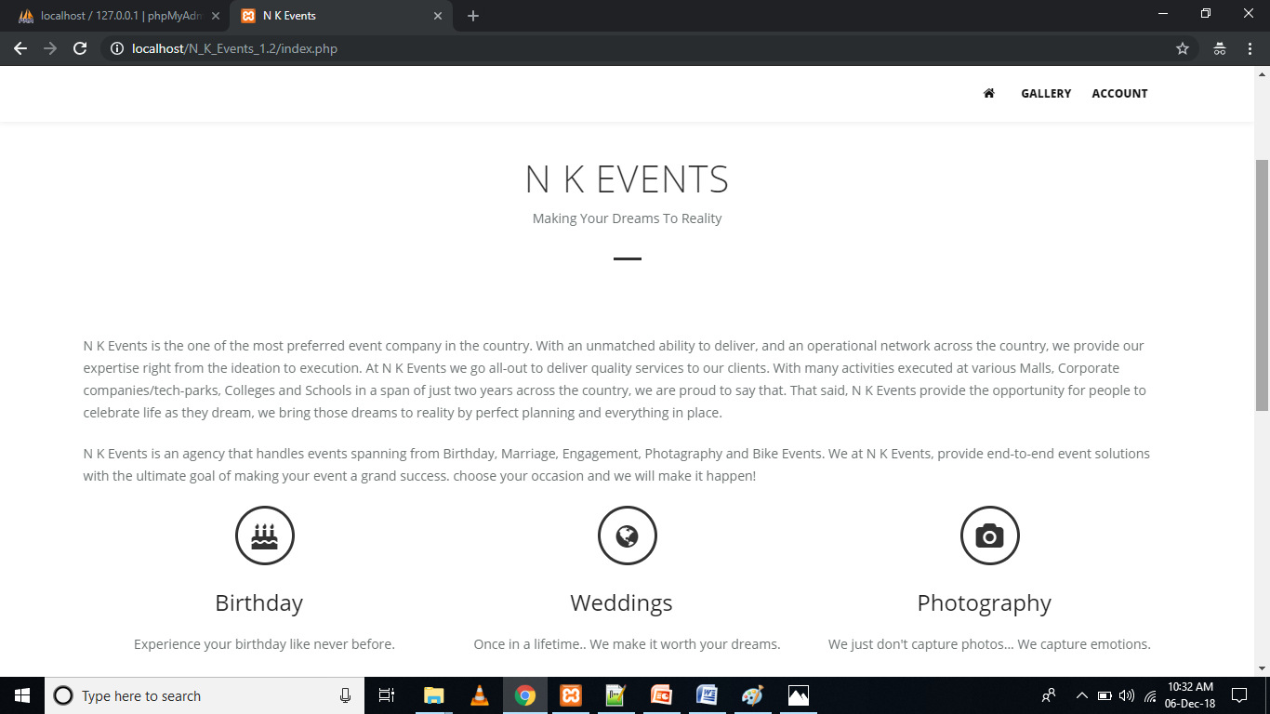

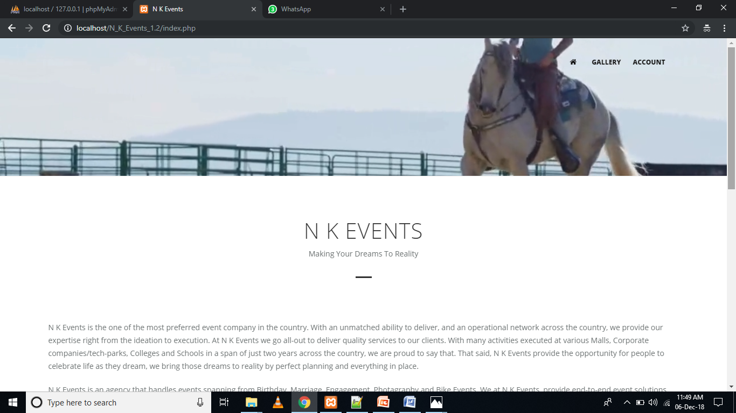

**11.Registration Page**

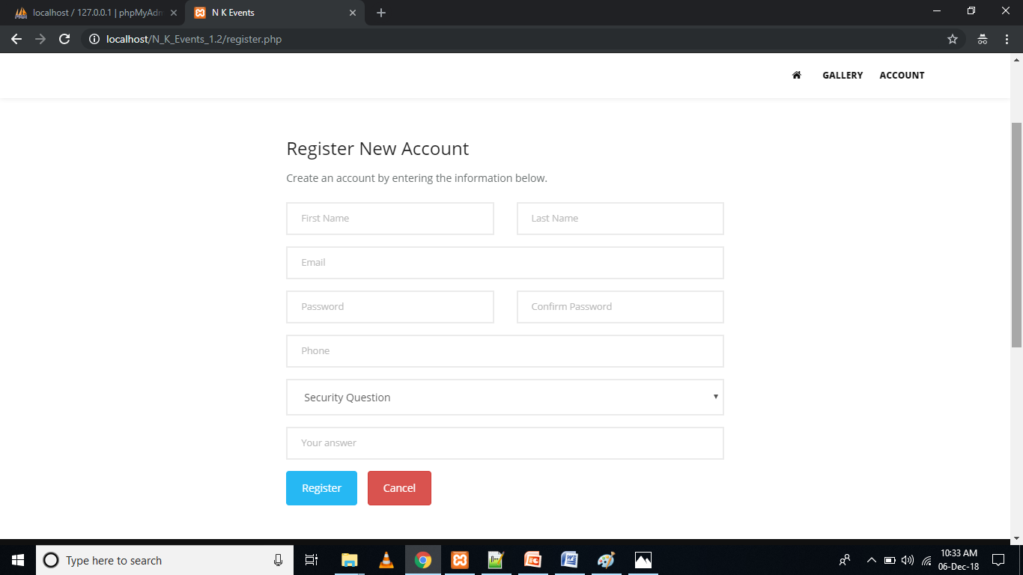

**11.3Login Page**

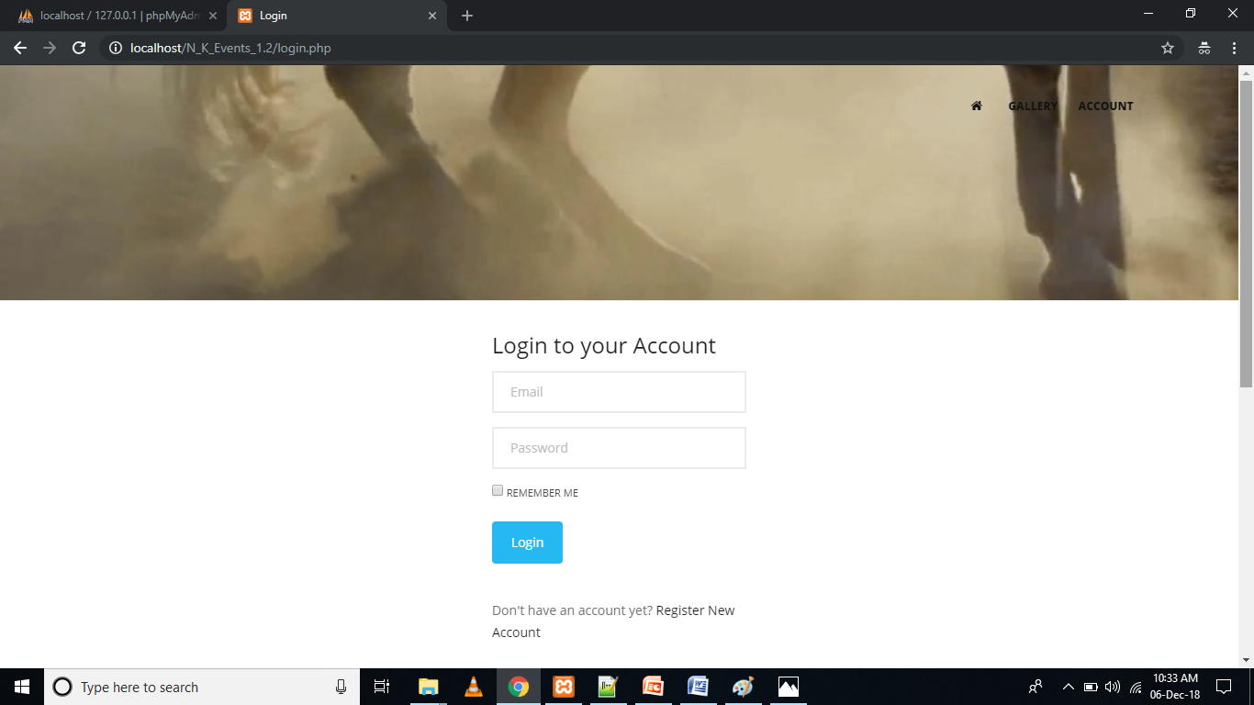

**11.4Gallery Page**

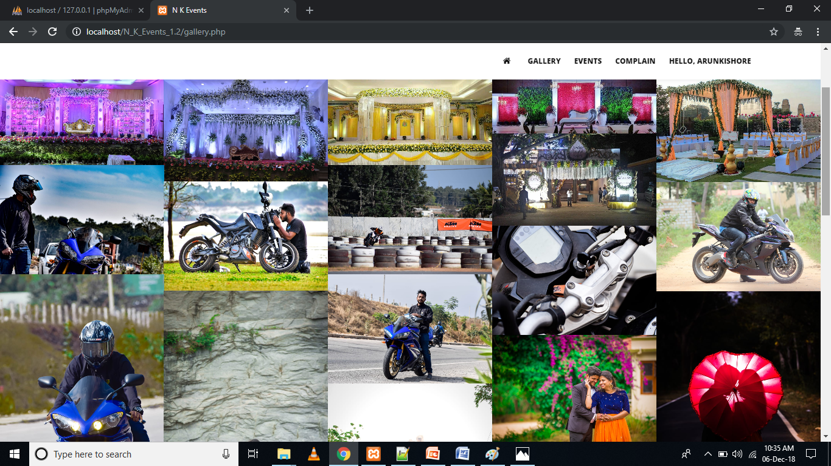

**11.5 Birthday Event**

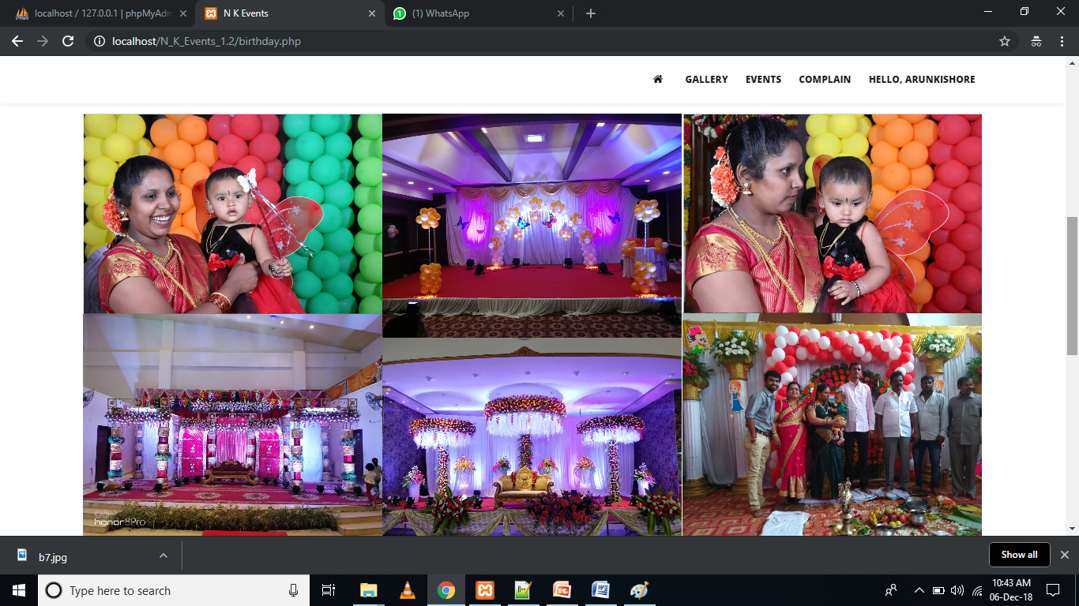

**11.6 Wedding Event**

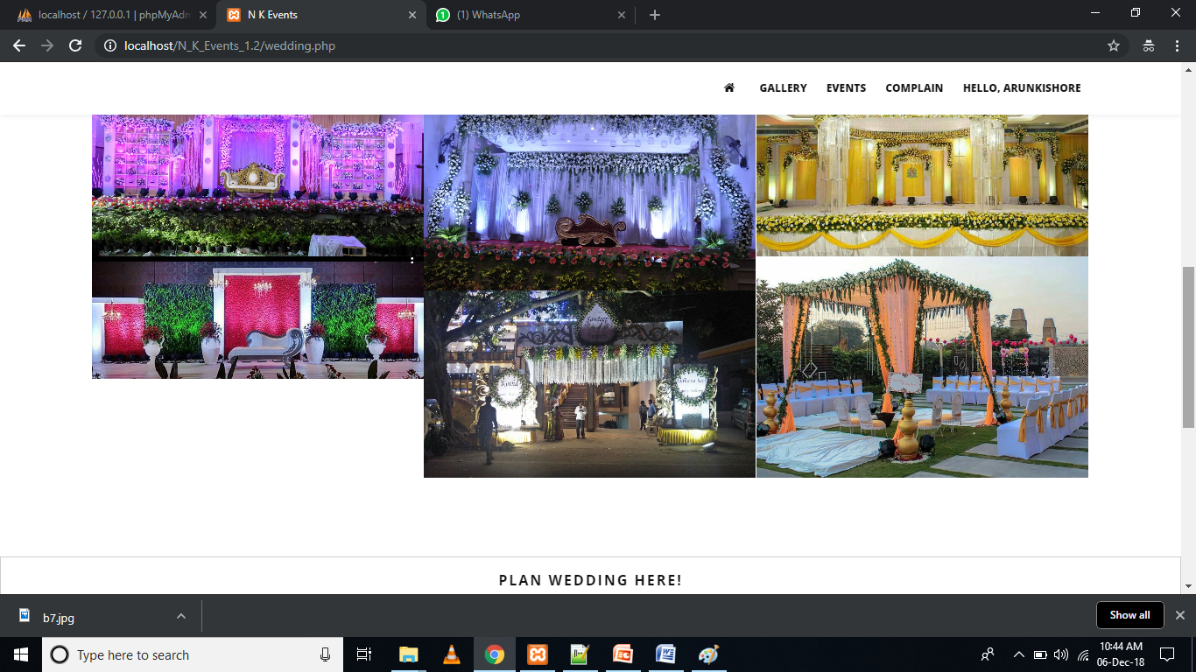

**11.7 Photoshoot Event**

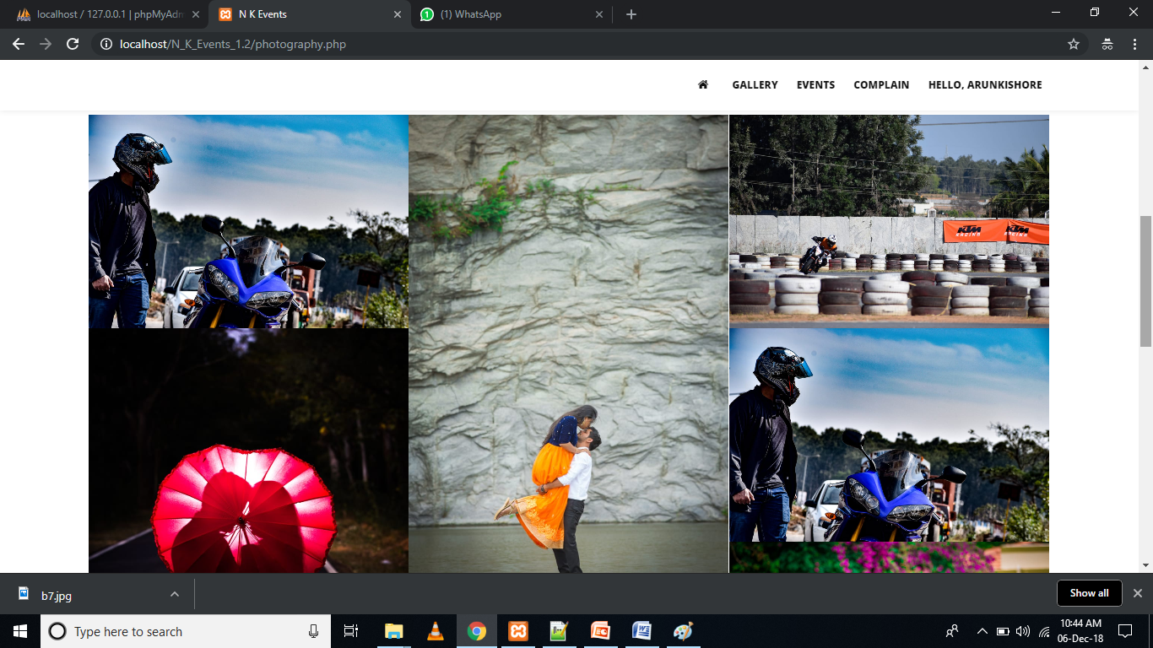

**11.8 Birthday Register**

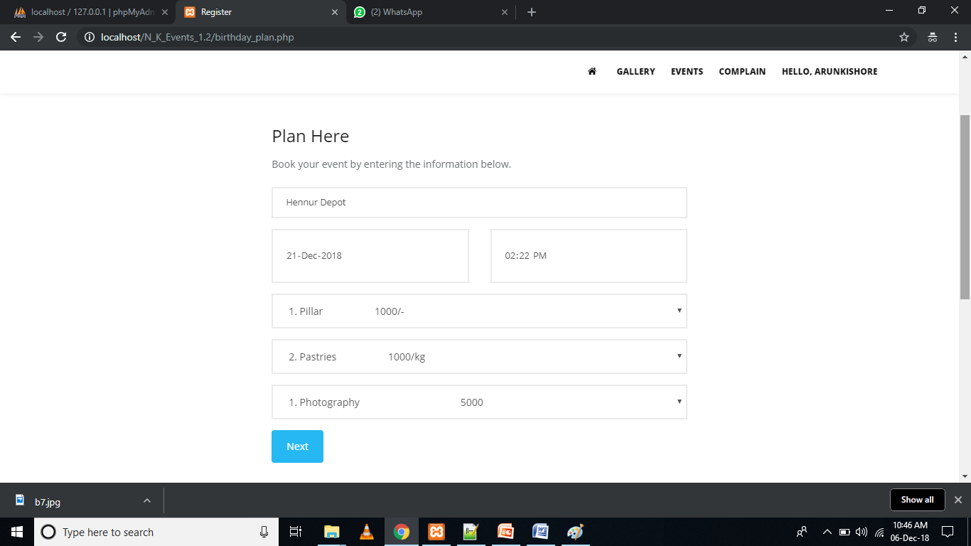

**11.9 Wedding Register**

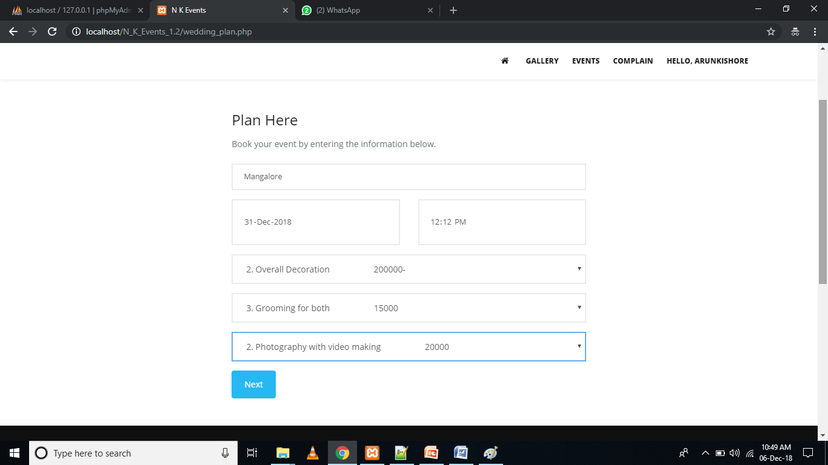

**11.10 Photoshoot Register**

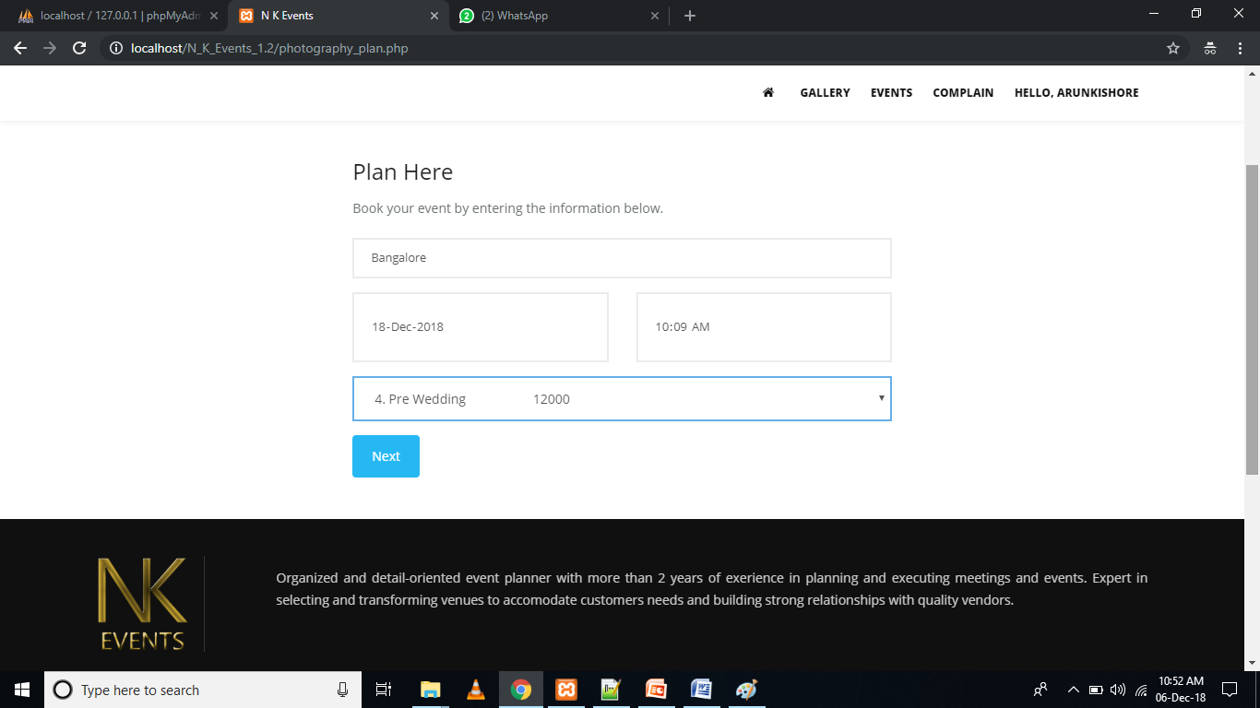

**11.11 Pay U Money Register**

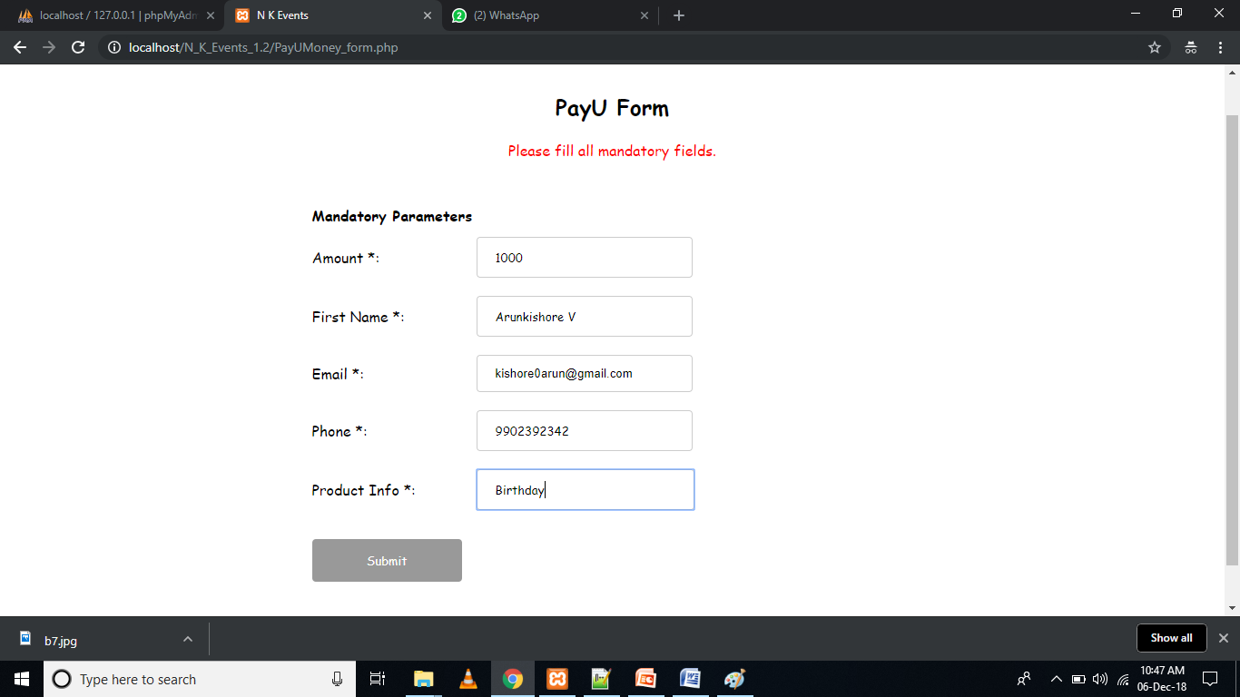

**11.12 Pay U Money**

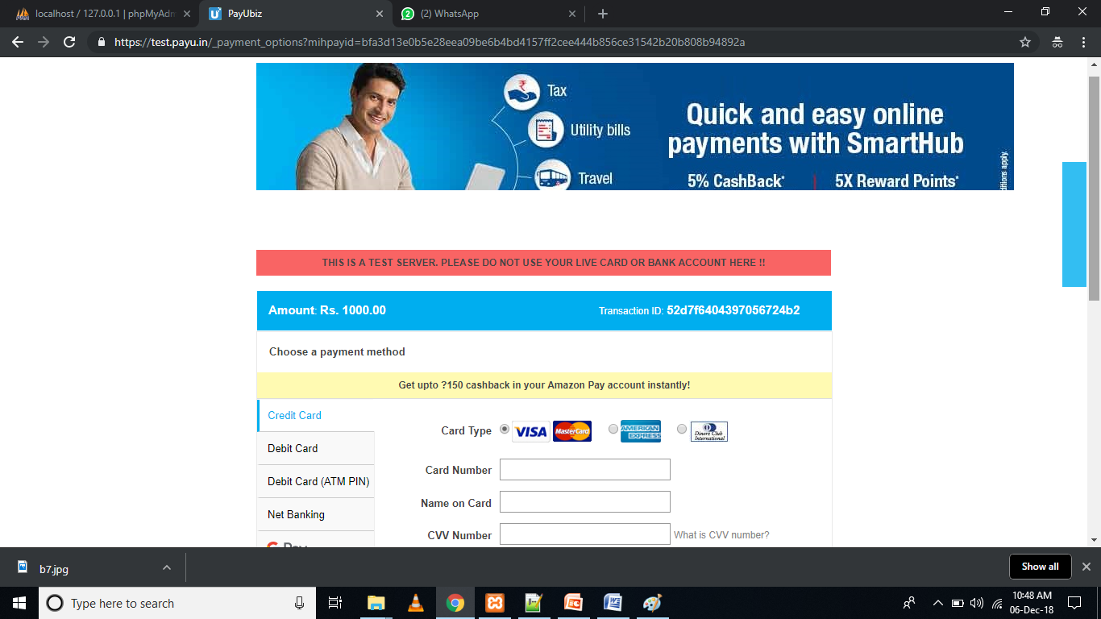

**11.13 Feedback**

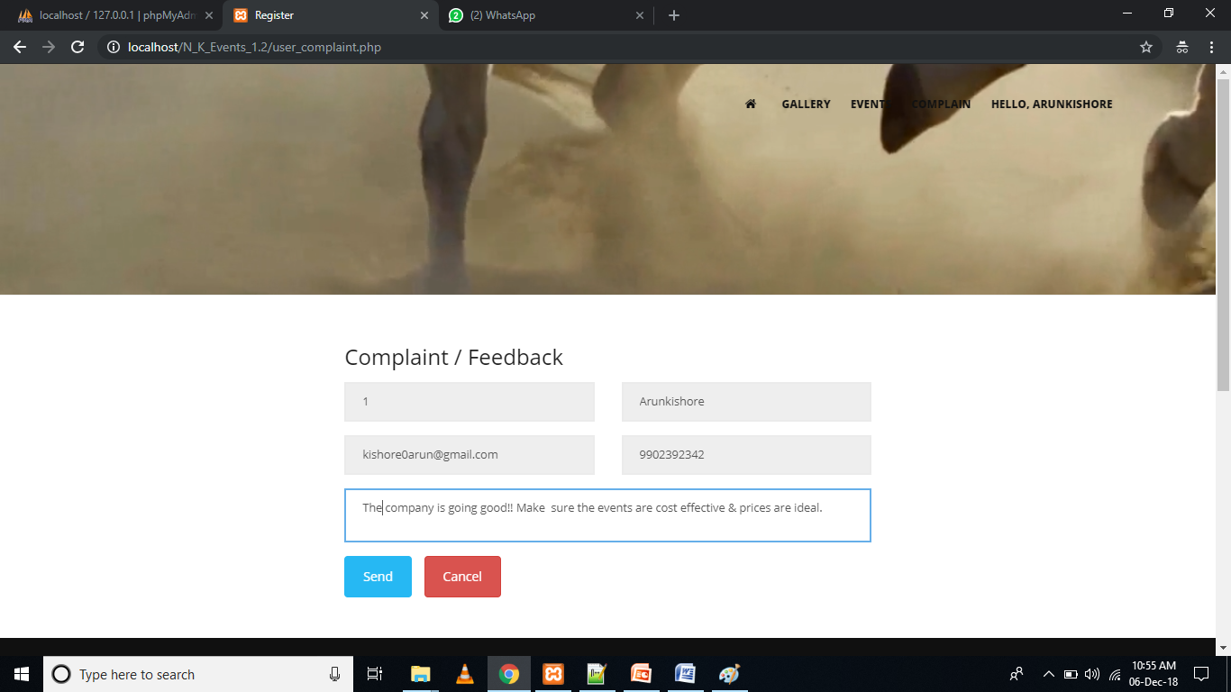

**11.14 View Profile**

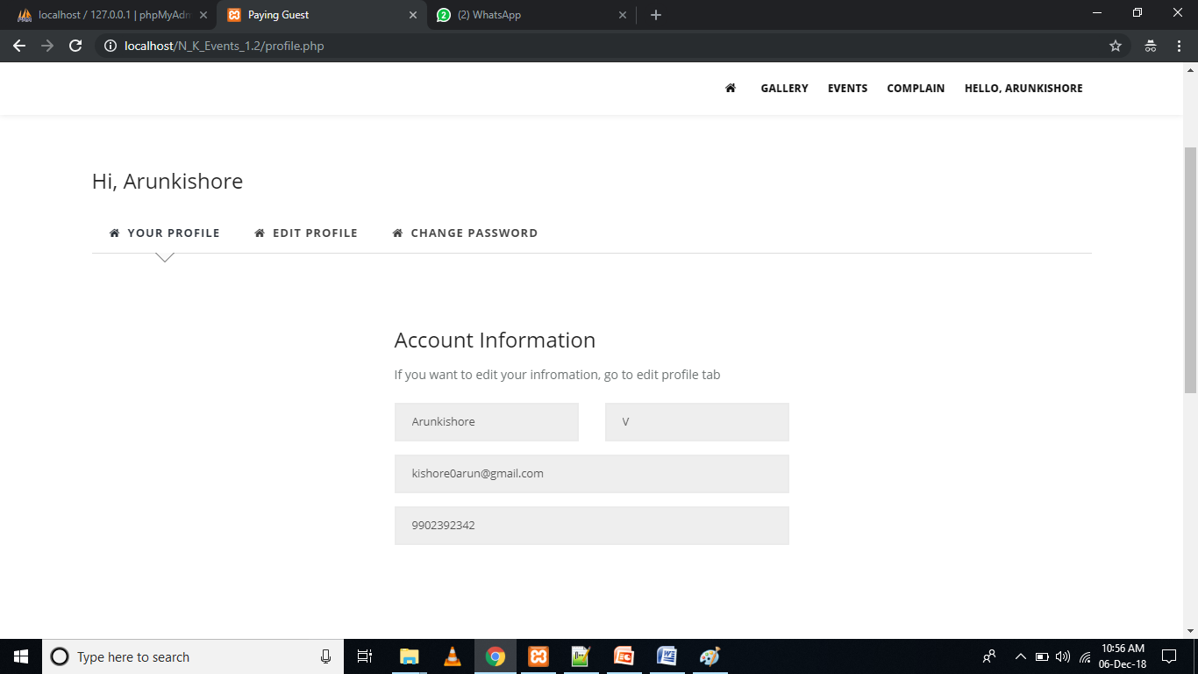

**11.15 Edit Profile**

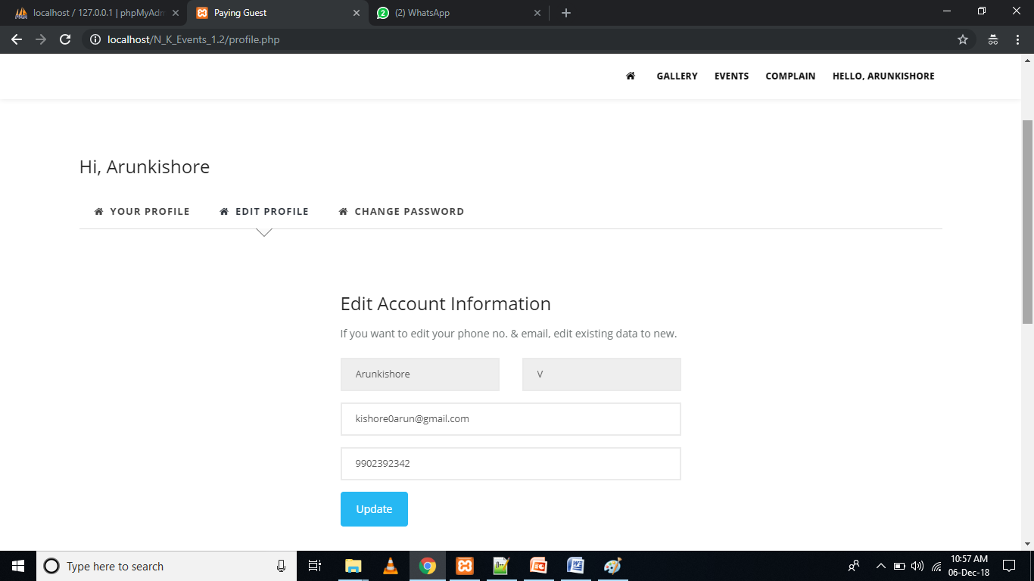

**11.16 Change Password**

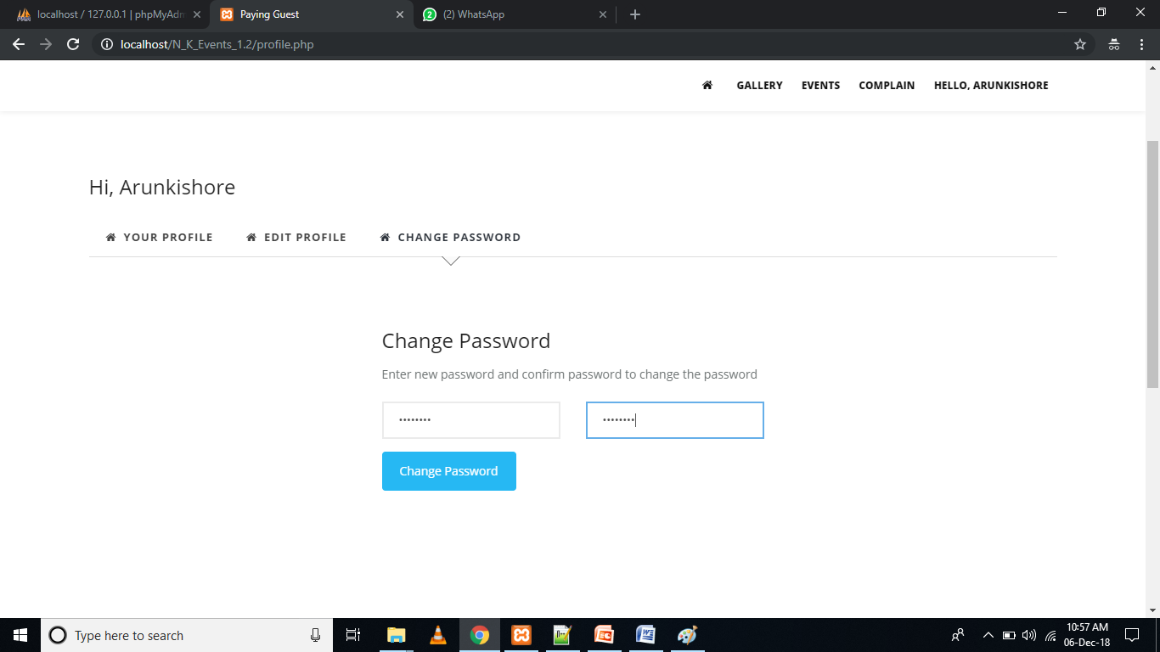

**11.17 Birthday Booked Reports**

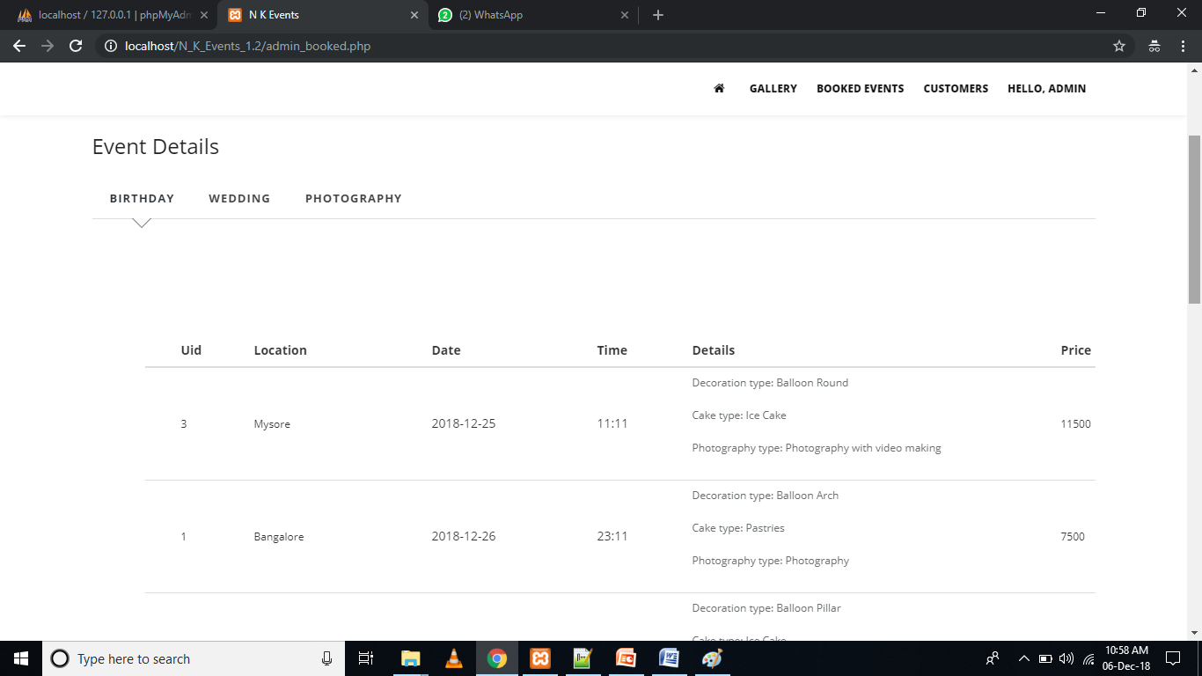

**11.18 Wedding Booked Events**

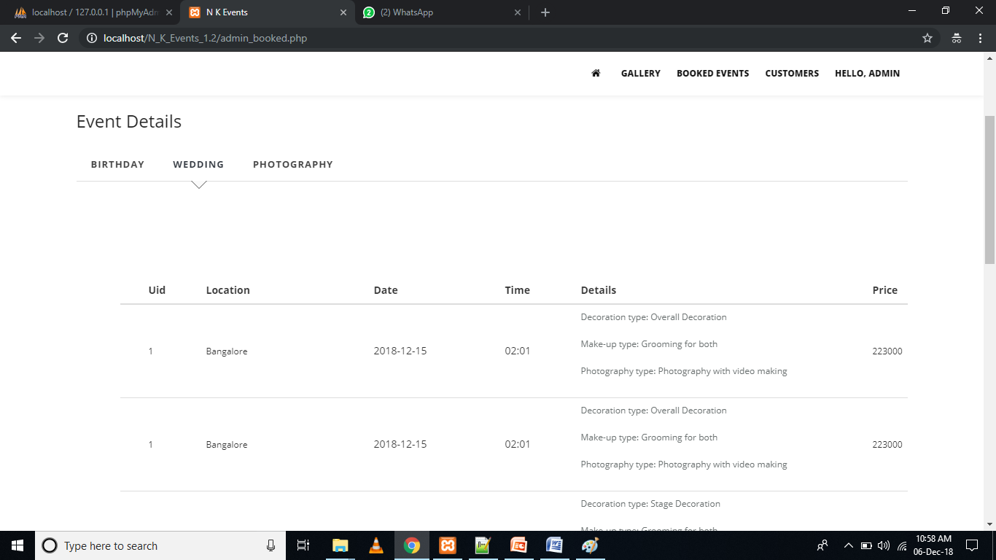

**11.19 Photoshoot Booked Events**

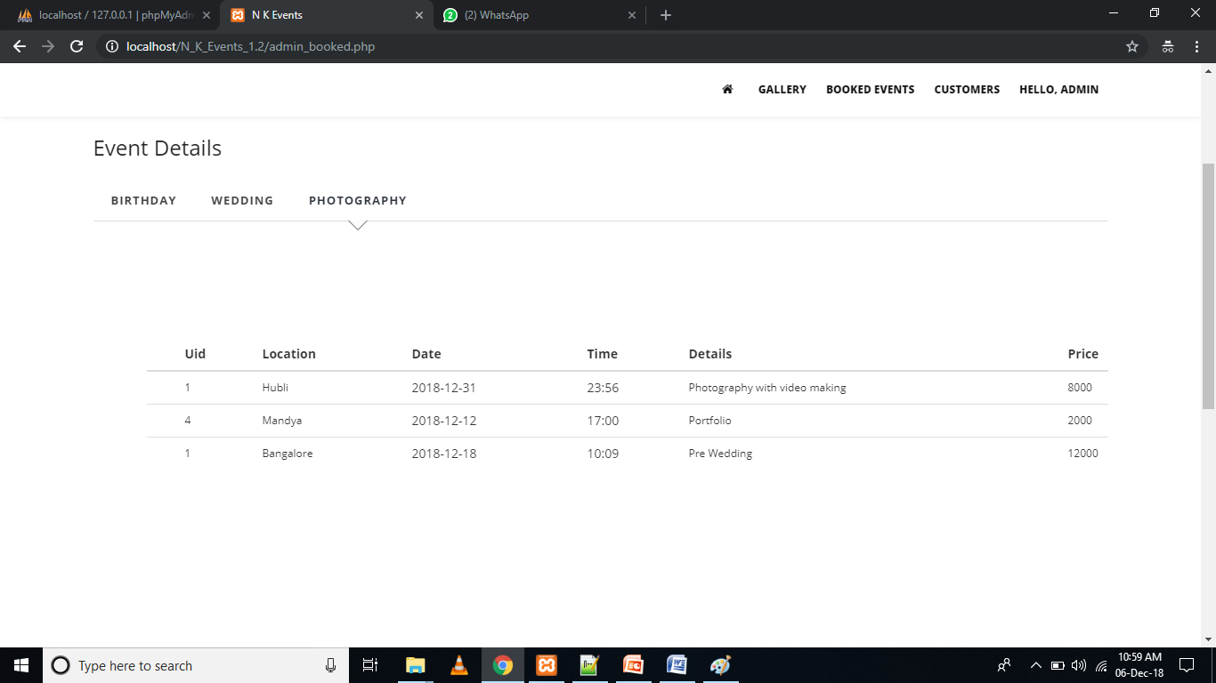

**11.20 Customer Details Report**

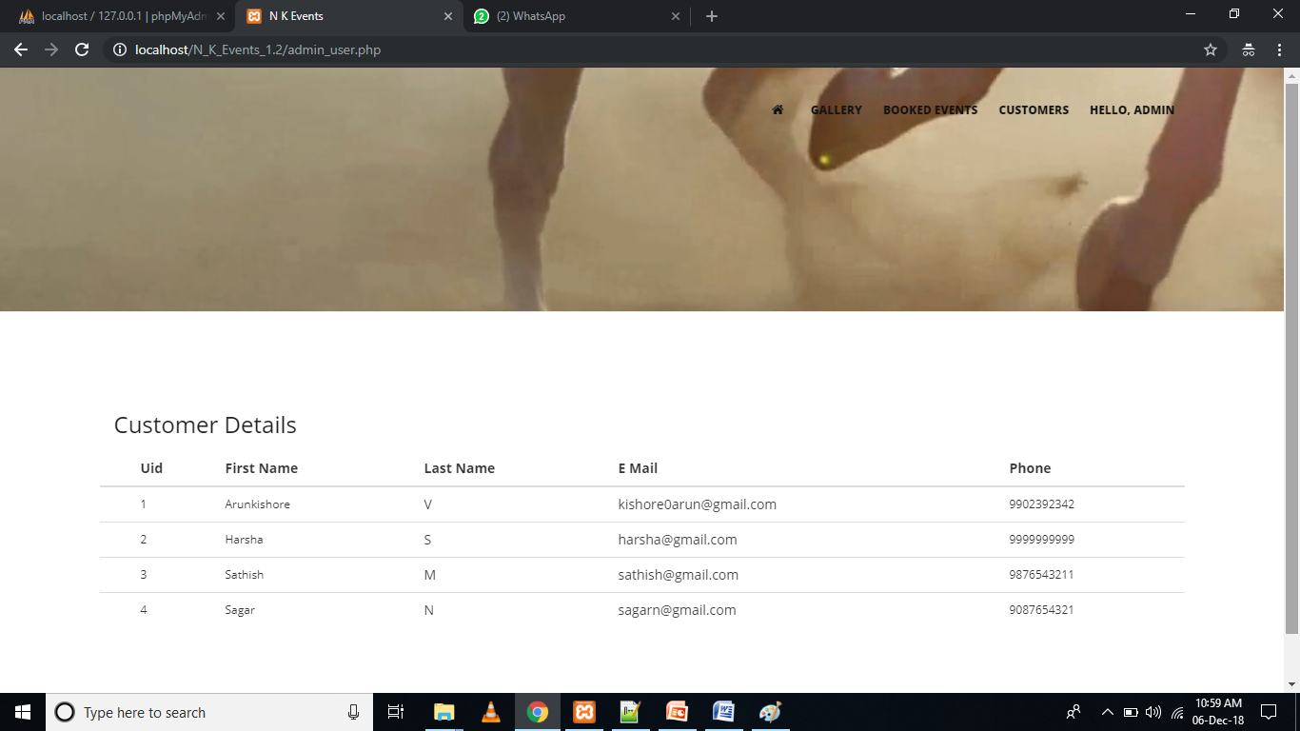

**11.21 Feedback Report**

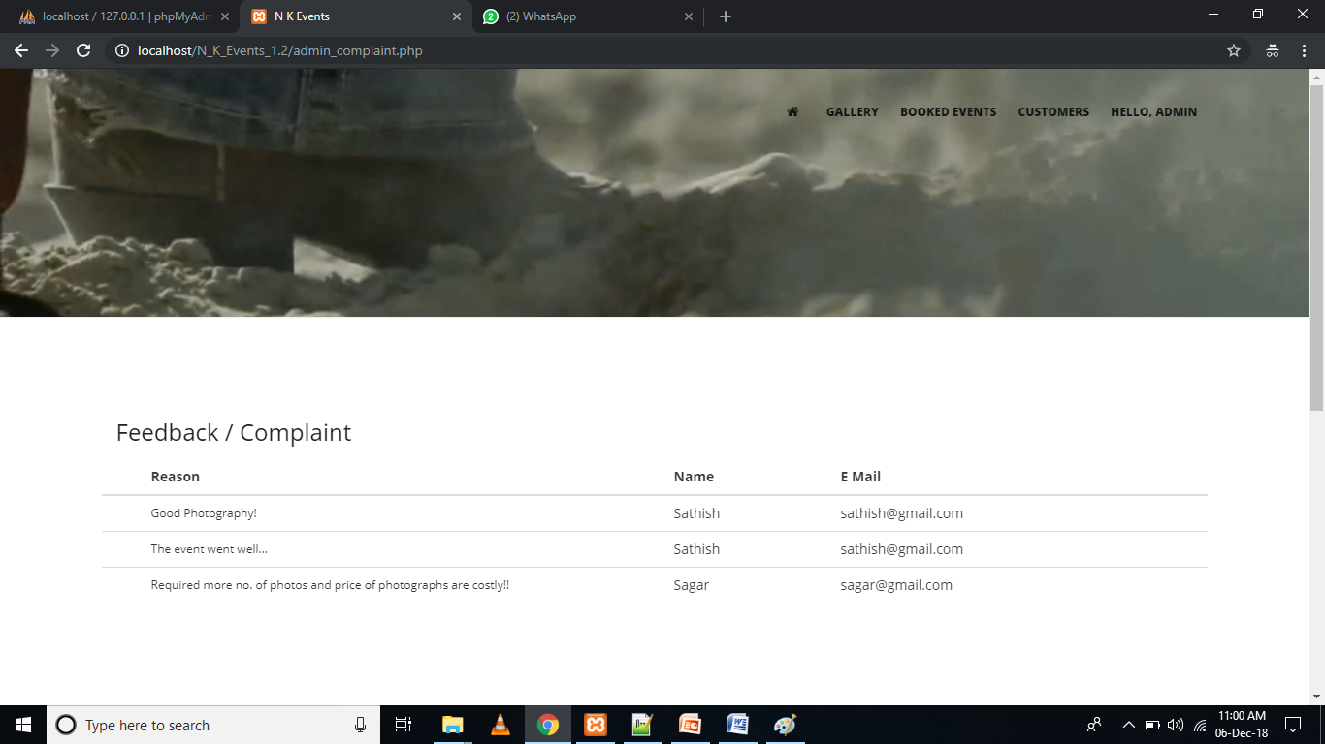

**12. Appendix: User Manual**

**Website**

**For Admin:**

**Login**

* The admin will first open the website and select Admin login from the menu bar in the Home page.
* He/she will enter the login credentials i.e., valid username and password and clicks on login button.
* Admin is directed to the customer details page.

**Admin Home Page**

* AdminHome page contains table with details, customer ID, type of event, day, time, name of the customer, phone and email ID.

**Customer Query Page**

* AdminHome page contains a link ‘click here for customer query’ in the navigation bar. If the admin clicks on the link he/she will be taken to customer query page which contains table with details like name of the customer, email ID, subject and the message which are sent by the customers.

**Logout**

* To logout the website the admin has to click on Logout button in the navigation bar.

**For User:**

**Events Page**

* User can view the upcoming events by clicking on the ‘Events’ in Home page.

**Home Page**

* The user can book the events by entering the fields Event type, date-time, user name, phone, email ID and click on Book now.
* After successfully booking the user gets alert message.

**Customer Details Page**

* User can view his event name and amount and click on ‘proceed to pay’ to pay for the booked event.

**Pay U Form**

* By clicking on the proceed to pay button in customer details page, the user is navigated to Pay U form to fill his/her details which are mandatory.

**Payment Page**

* Customer can make the payment for the event by selecting payment option available.

**Send Feedback**

* Selects Contact from the navigation menu in the user home page. The customer is directed to Contact page where he can give the feedback.

**About Us Page**

* The customer can view the information of the NK Events in about us page.